Experiment 4 OpenCV
Perform basic Image Handling and processing operations on the image
• Read an image in python and Dilate an Image using Dilate function.
Program:
import cv2
import numpy as np
img = cv2.imread("flower.jpg")
kernel = np.ones((5,5), np.uint8)
dilated = cv2.dilate(img, kernel, iterations=1)
cv2.imshow("Original Image", img)
cv2.imshow("Dilated Image", dilated)
cv2.waitKey(0)
cv2.destroyAllWindows()
Input:
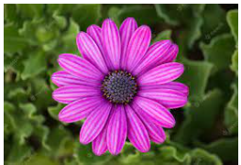
Output:
